**DOCKER METRICS**

1. Elastic agent should be installed , enrolled in the fleet and running on the remote instance.

**sudo systemctl status elastic-agent**

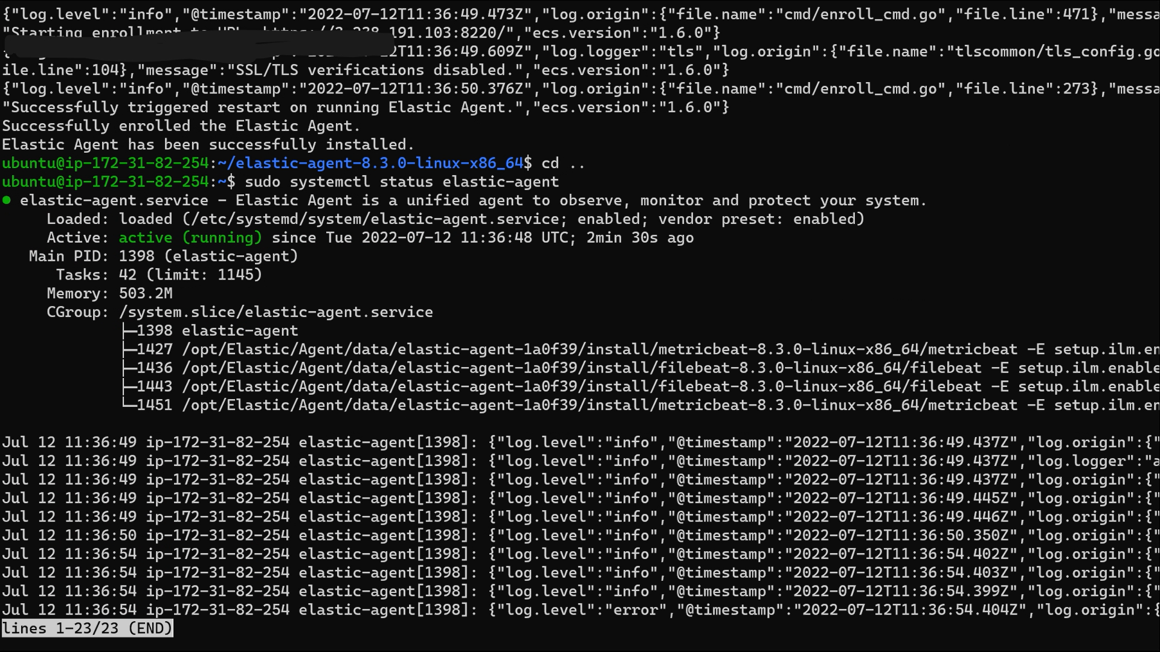

1. Install docker on the instance :

[**https://docs.docker.com/engine/install/ubuntu/**](https://docs.docker.com/engine/install/ubuntu/)

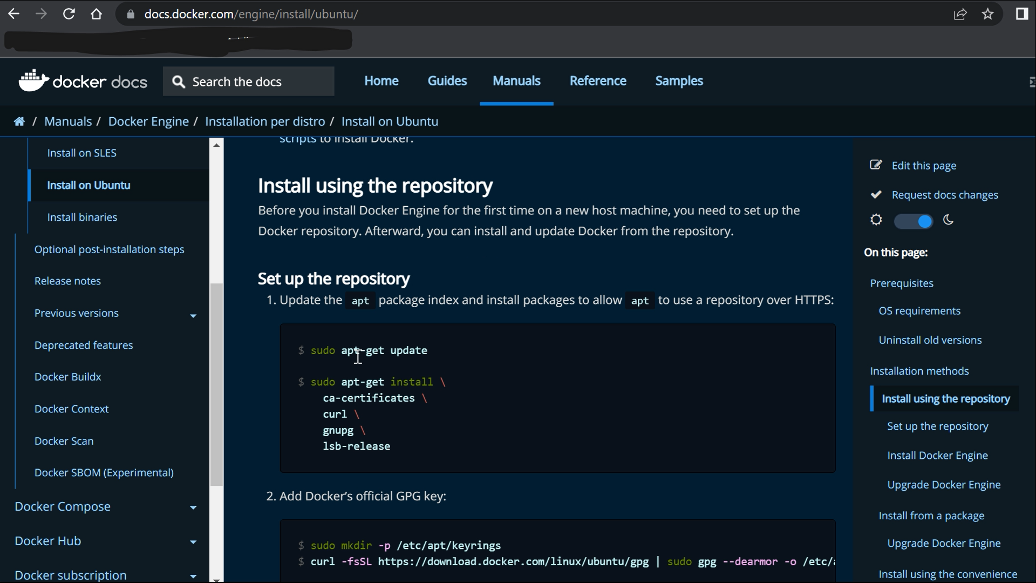

Pull an image and run a container on docker to monitor.

Eg: **sudo docker pull rathijaat001/weather-app**

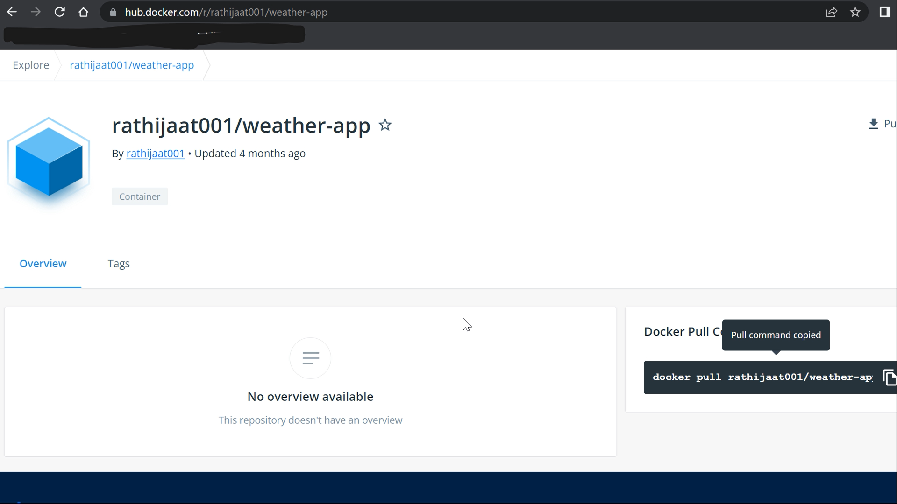

Run the image using:

**sudo docker run -d -p 80:80 rathijaat001/weather-app**

Check on <<instancePublicIp:80>>

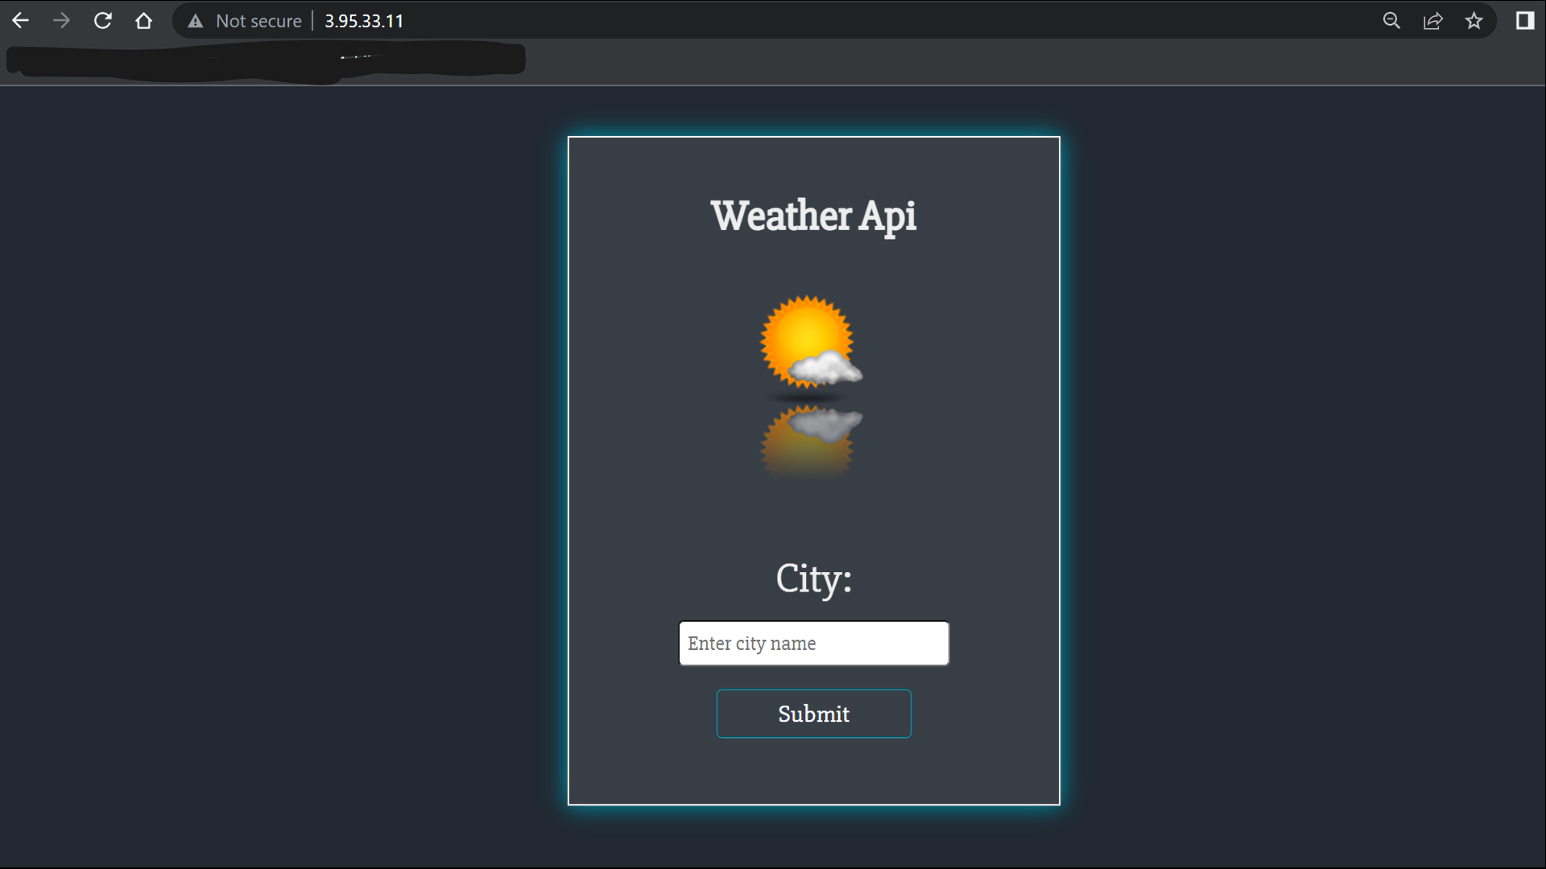

1. Go to the policy of the elastic agent on the remote instance. 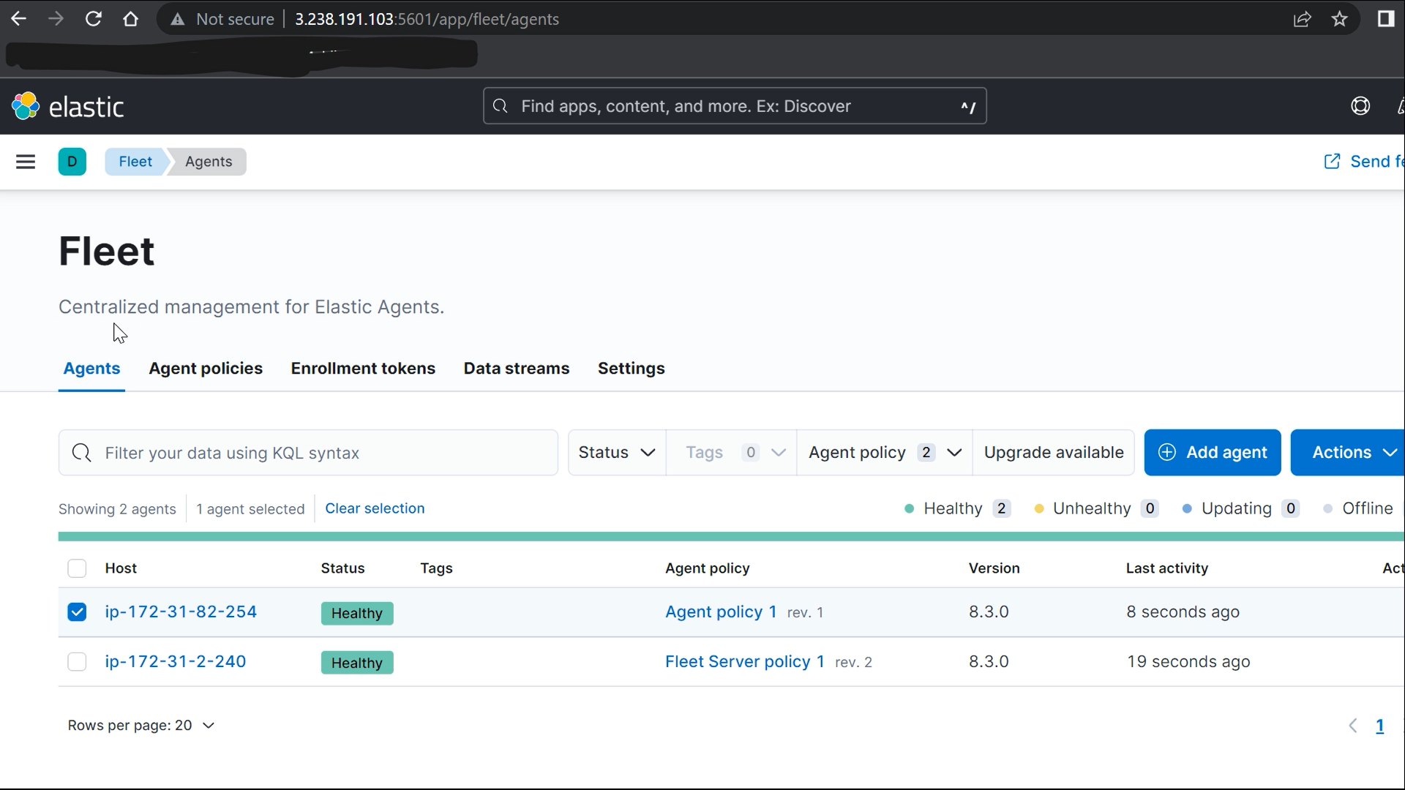

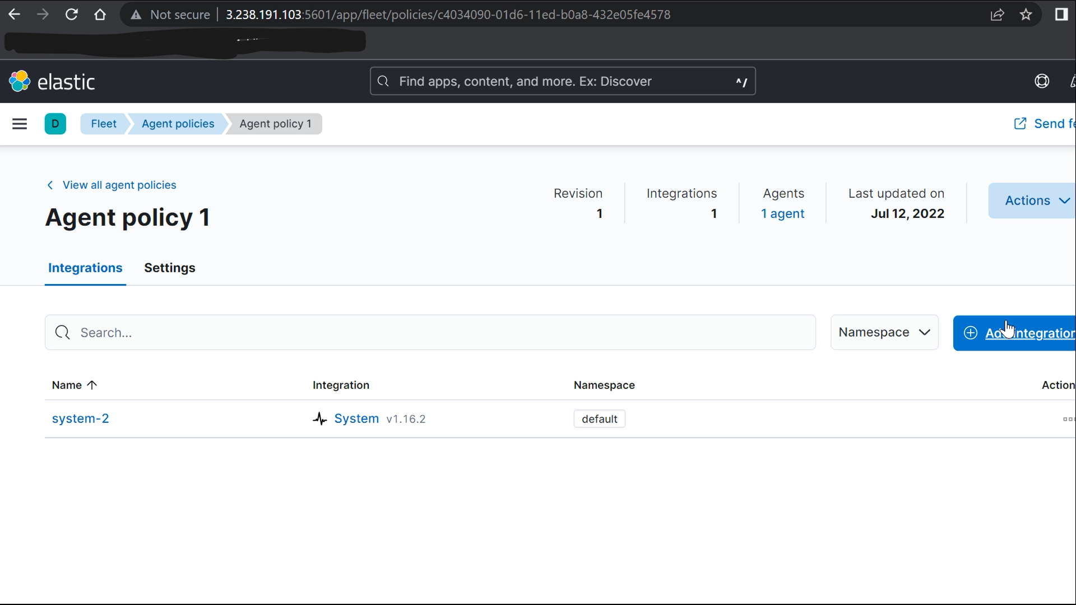

1. Click on Add integration , and search for *DOCKER METRICS*

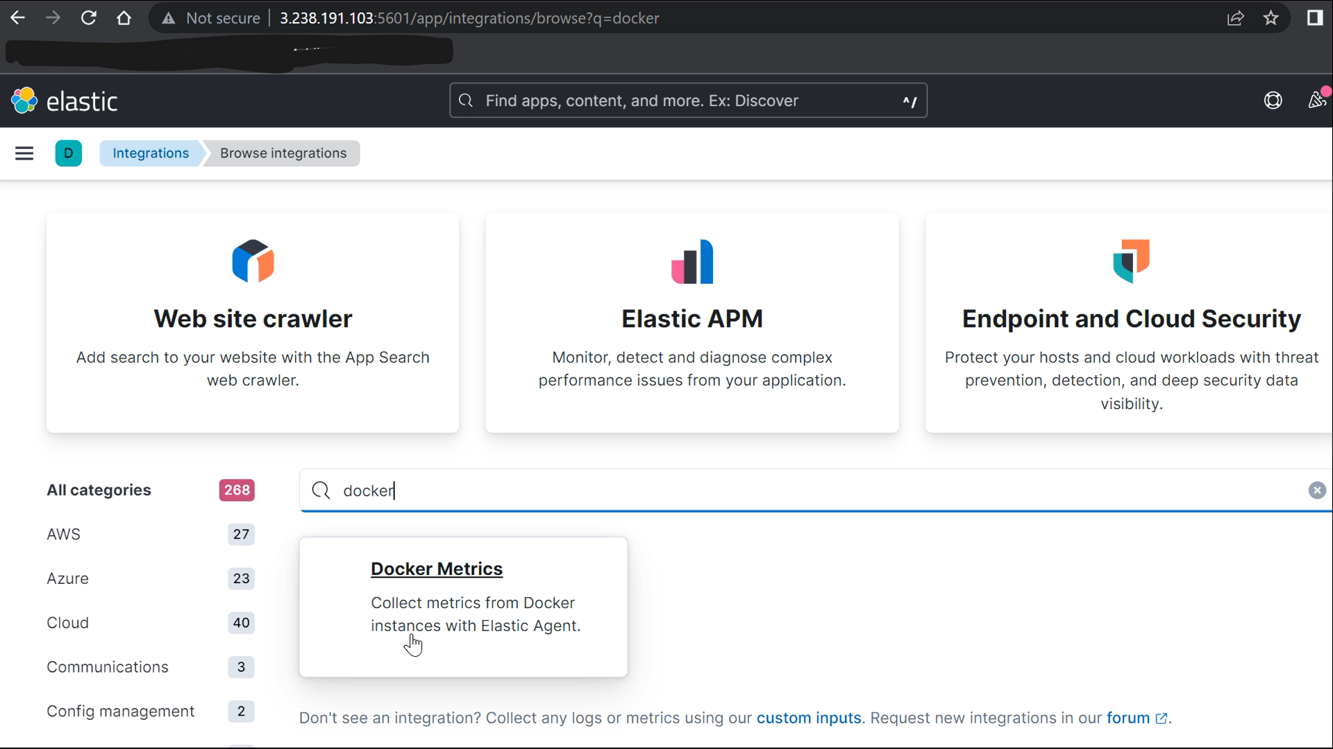

1. Click on add integration and select Remote Agent policy to add the integration.

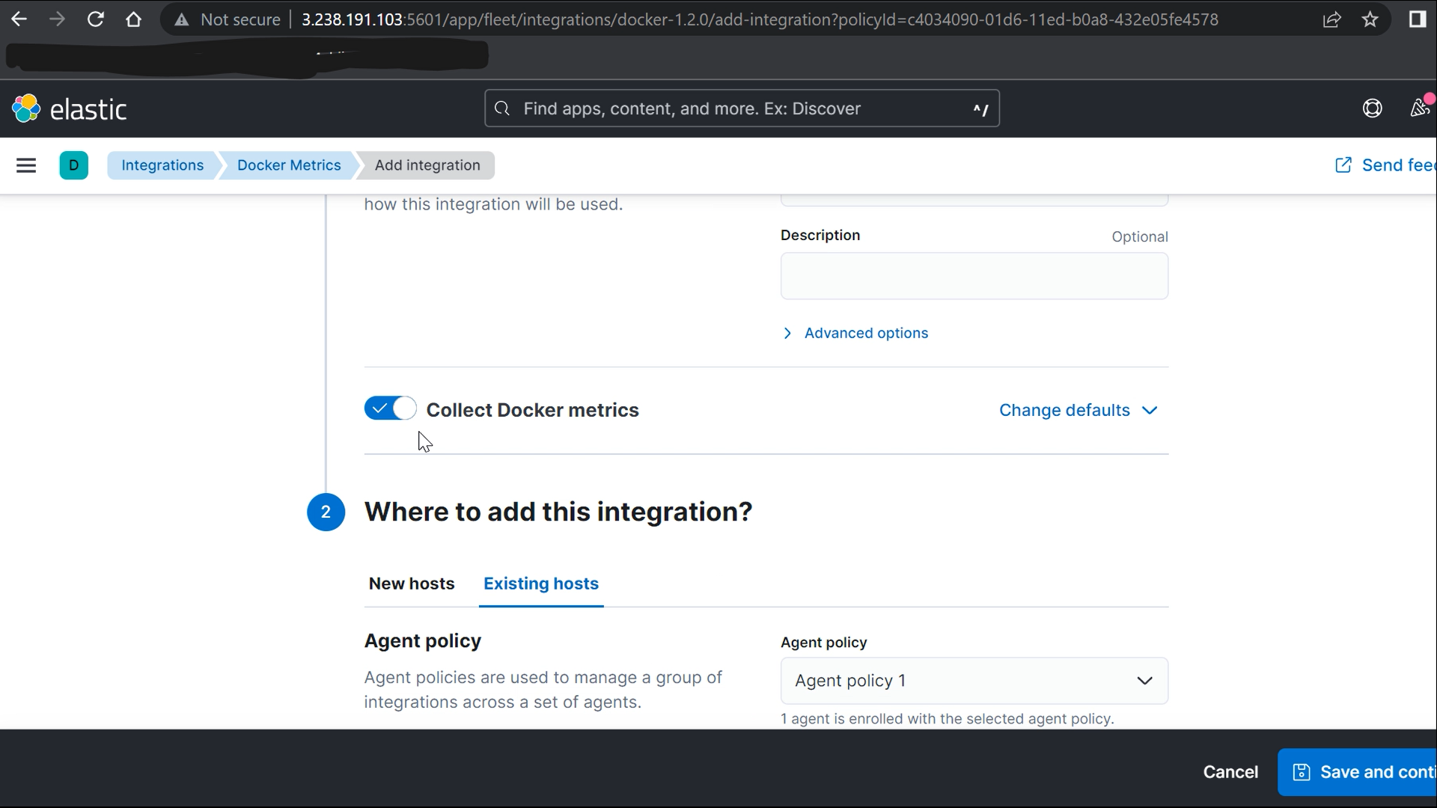

1. Click on save and deploy and the integration will be added.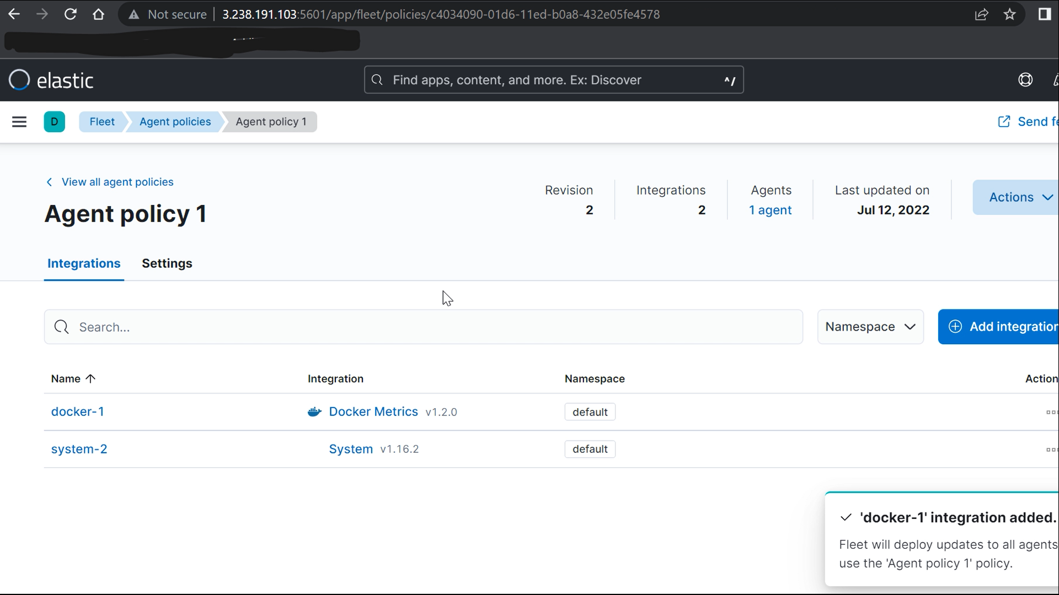
2. Go to data stream and select view dashboard to go to docker dashboard.

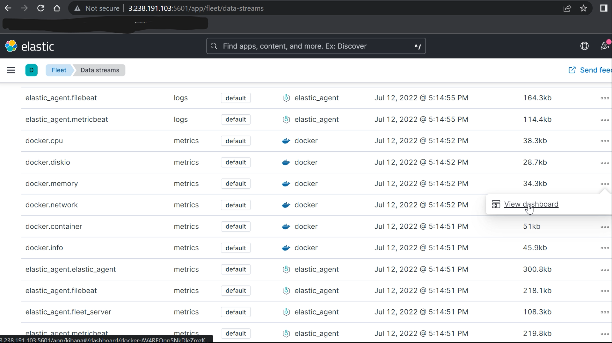

1. Docker dashboard will look like :

